1. validate function in register.html doesnt work
2. After creating the registration page and inserting values, a page comes up echoing the code rather than having a pop up similar to the screenshot in Page 5 of the Part 1 Assignment.

This is my result after submitting values:

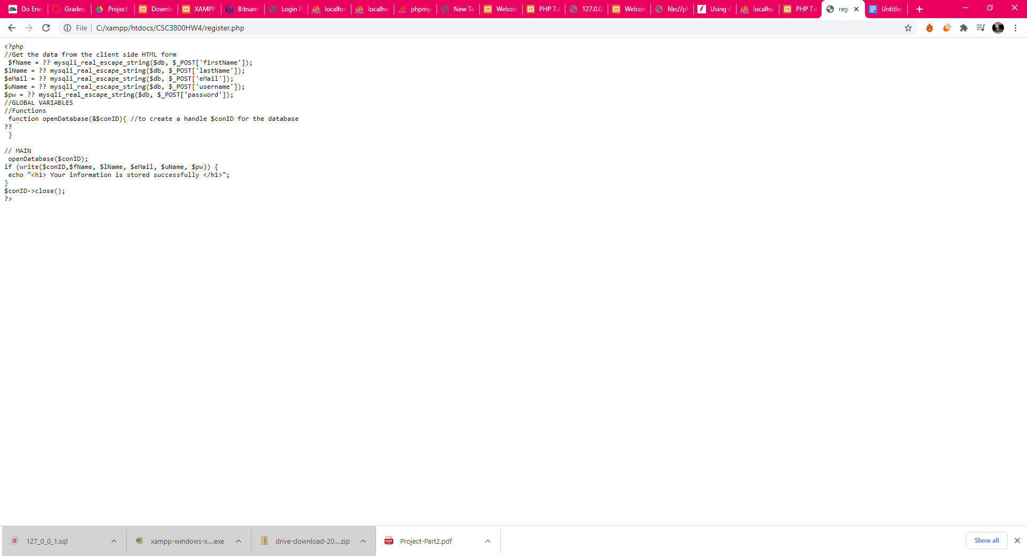

I intended to laid a page similar to this:  
